Full-Choice Ballots  Only a small group can crowd around a tally board.  Big groups use paper ballots, tallied by computer.  Old-fashioned ballots oversimplify most issues. They let you mark only one option “yes”, leaving all others “no”. This creates false dichotomies leading to social polarization and unnecessary conflict.  Full-choice ballots reduce those negative effects. They let a voter rank his 1st choice, 2nd choice, 3rd etc. Ranks often reveal the dichotomies, “us versus them” or left versus right, hide moderate points of view.  ❶ ❷ ❸  VOTE HERE Fill only one “O” on each line.  Best Ranks Worst  Names 1st 2nd 3rd 4th 5th 6th  John McCain O O O O O O  Barack Obama O O O O O O  Hillary Clinton O O O O O O  John Anderson O O O O O O  Ross Perot O O O O O O  Ralph Nader O O O O O O  Michael Bloomberg O O O O O O  Write In O O O O O O  © 2008, Robert Loring VotingSite@aol.com |  |  | Get your hands on 5 great voting rules.  See fair-share tallies organize voters.  Vote fast on budgets, reps and projects.  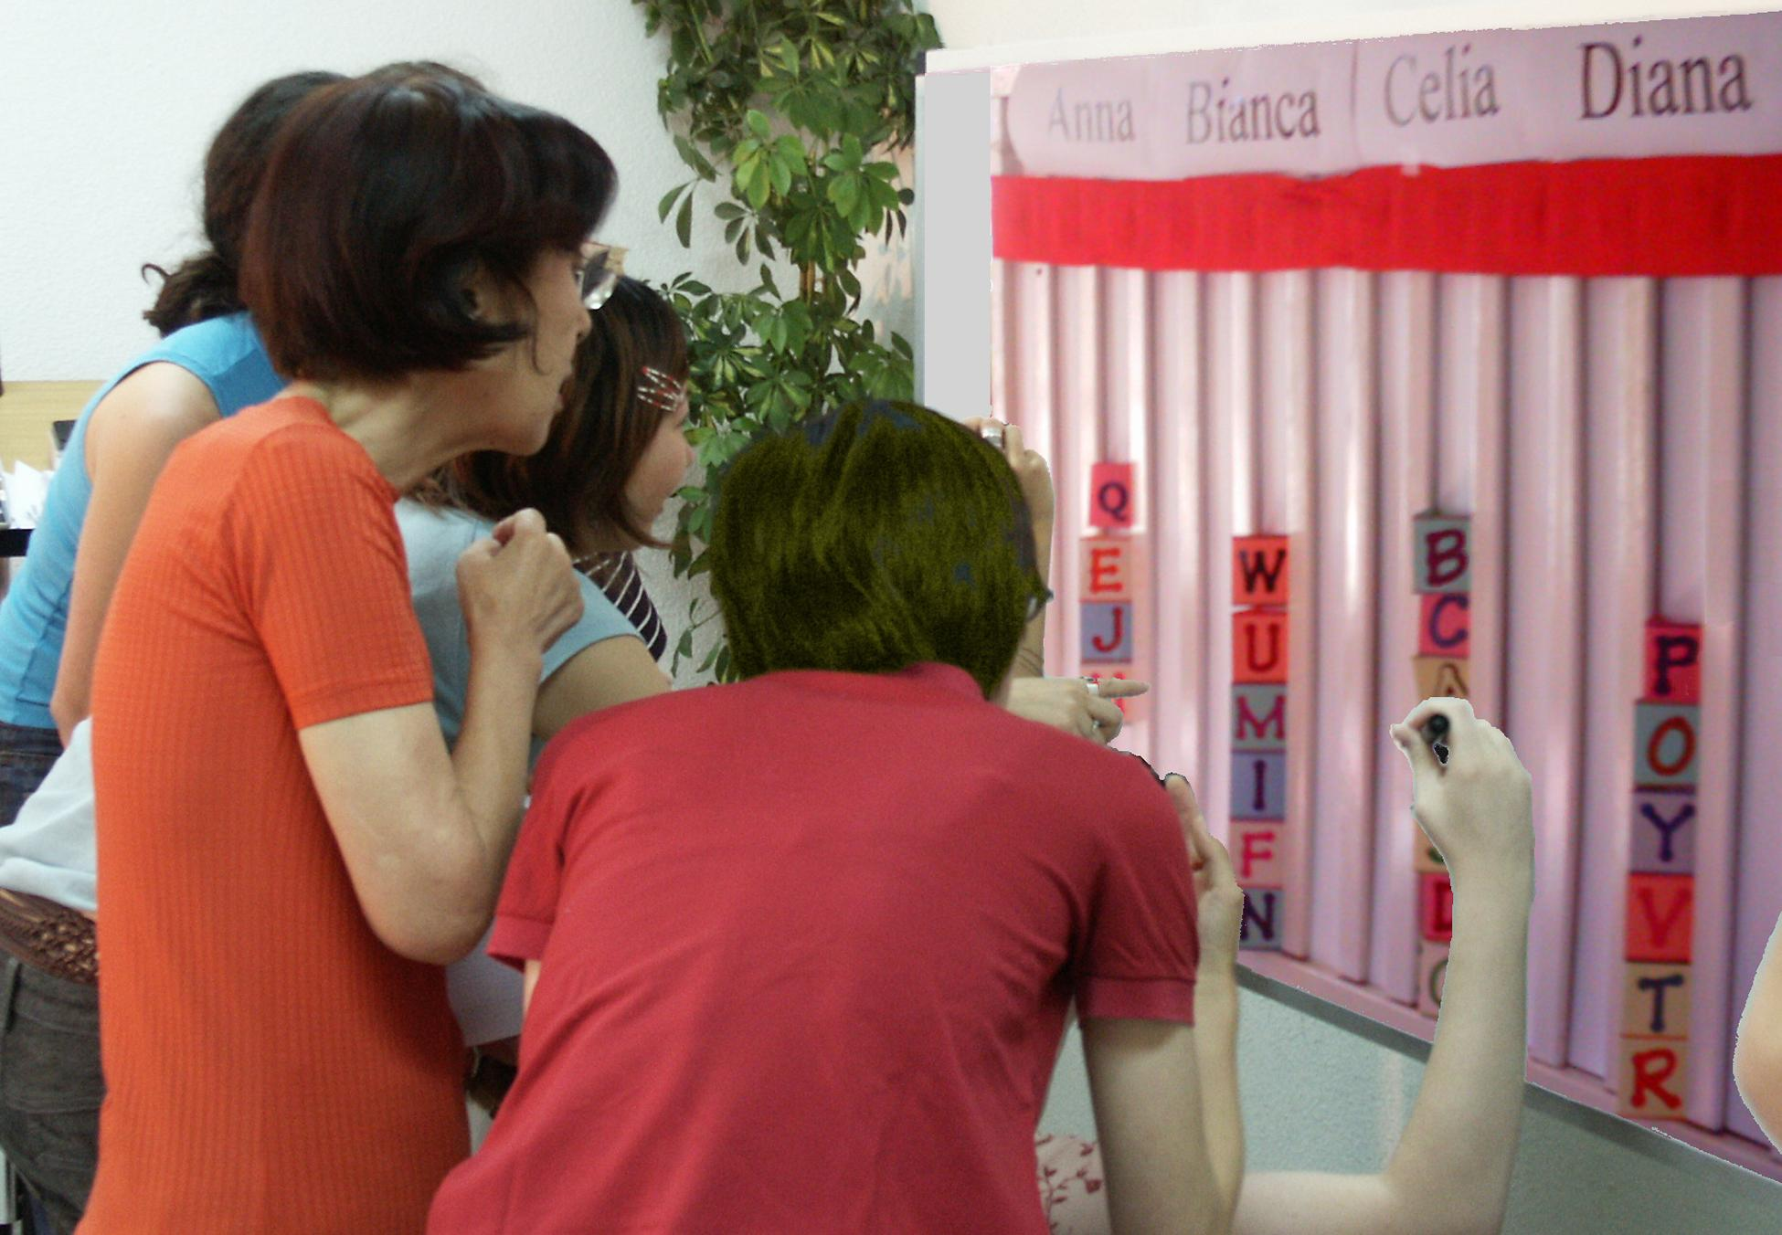  A tally board has   A card for each voter,  A column for each option,  A finish line for the favorites.
Budget Refill Votes Adjust Departments   A big department has several columns to fill.  The columns each need $100... for the department  to reach last year’s budget; that's its refill line.  A supporter’s cards help refill its budget columns.  Voters can push it above its refill line.  But its gain will be another department's loss.  Let's say a council of 20 decides each program needs modest support from 10 members to restore its funding.  So a column needs 10 cards from 10 voters to reach its refill line, or as few as 5 double cards from eager voters.  The group wants to budget 4 low-cost activities with 1 column each, plus 3 costly programs with 2 columns each. Those 10 columns X 10 cards to refill each = 100 cards.  The 100 cards / 20 voters = 5 cards for each voter; that's 1 double and 3 singles. You may put only 1 in a column.  Set target budgets and rank your priorities.  If a budget goes over your target, its priority drops.  So move your cards to your under-funded priorities.  We stop moving cards when a hidden timer sounds.  You lose cards that are not on the board.  This deters faking votes until a last-moment switch.  A supermajority may reopen the voting.  10. Did departments need a winning number of votes?  11. Did your second choice hurt your first choice?  12. Should a rep’s cards be so visible to voters?  13. Who could use Budget Refill Voting?
  Celia  IRV Winner |  | Diana  Runner up
  Finish Line__Finish Line__Finish
  B B
  J J |  | G G
  T T |  | D D
  K K |  | Z Z
  V V |  | C C
Instant Runoff Voting Elects 1 Winner  For a tabletop tally by Instant Runoff Voting:   The finish line marks the height of half the cards +1.  That is how many votes a candidate needs to win.  Eliminate the weakest candidate if no one wins.  Draw names from a hat to break ties.  Move your card if your candidate loses.  This is a “movable vote.”  Repeat until one candidate reaches the finish line!  This chart shows four columns on a tally board.  The rule eliminated Anna, so voter JJ moved his card.  Then Bianca lost, so BB and GG moved their cards. |  | Read full answers at web site: BRV: no, no, yes, ___. Pairwise: yes, mid, yes, balanced, no. | Pairwise Tally Centers a Policy   Flag C stands at our center, by the median voter.  Three flags surround C, about 5' from it.  Pairwise asks: “Are you closer to flag A than B?  If so, please raise 1 hand.” Then A against C, etc.  We put each total in the Pairwise table below.  The winner must top every rival, one-against-one.  A pole stands at our center, by the median voters.  It holds a short Red ribbon and a long Blue one.  If the Red ribbon gets to you, the Red policy gets your vote with its narrow appeal.  But if the Red cannot touch you, the wide appeal of the Blue policy gets your vote. Which one wins?  If the flags are places for a heater in an icy cold room:  14. Do we turn on its fan to spread the heat wide?  15. Put it at our middle or in the biggest group?  16. Do voters on the fringes have any influence?  17. Did the middle voter enact any policy alone?  18. Did this favor a balanced or a one-sided policy?  19. Should a first-choice vote count more?
  Anna  Eliminated 1st |  | Bianca  Eliminated 2nd
   |  | B B
  J J |  | G G
  against | A | B | C | D
  for A | — | 2 | 2 | 3
  for B | 5 | — | 2 | 3
  for C | 5 | 5 | — | 4
  for D | 4 | 4 | 3 | —
Instant Runoff Voting cont.  By organizing voters, Instant Runoff Voting avoids:  Spoiler candidates and the lesser-of-two-evils choice;  Costly runoffs and winners-without-mandates.  IRV elects leaders in London, Sidney, San Francisco...  It elects students at Duke, Rice, Reed, MIT, UCLA…  1. How can your group use this voting rule?  2. A card that moves is no bigger than any other: T, F  3. Your 2nd choice vote can’t hurt your 1st choice: T, F  4. Only one candidate can reach 50% + 1 vote: T, F  Single Transferable Vote Elects 3 Reps  For a 3-seat election by Single Transferable Vote:   The finish line is set at 1/4 of the cards + one.  Do not give a card to a candidate who has finished.  Eliminate the weakest candidates one at a time.  Move your cards until three candidates win!  STV is used in many Australian and Irish elections, at Princeton, Harvard, Berkeley, Oxford and Cambridge,  in some unions and in the Church of England.  STV gives each group their fair share of council seats.  It elects more women and political minority candidates.  It increases choices for voters and turnout of voters.  It increases the effective votes, those which elect reps.  5. What total percent must three STV reps win?  6. Only three candidates can win 25% + one vote: T, F  Ask questions one thru three with each voting rule. |  | Answers: IRV: __, T, T, T. STV: ³/₄, T,. MMV: no, your option, no, no. | Movable Money Votes Buy Public Goods  For Fair-share Spending by Movable Money Votes:   Let's say we each put in $1 to buy some items.  You get two 25¢ voting cards and a 50¢ card.  We say an item needs modest support from 8 of us  to prove it is a public good worth public money.  So the finish line marks the height of 8 cards.  You may put only one of your cards in a column.  So you can't dump all your cards on a private item.  Tip: Give your double card to your favorite.  This way 4 eager voters can fund a low-cost item.  A costly item must fill several columns. A column  here holds $2, so a $4 item must fill two columns.  When an item wins, the banker hides its cards. We  drop any item that costs more than all the cards left.  Then one at a time, we drop the least popular item, with the lowest level of cards in its columns.  Move your card from a loser to your next choice.  Tip: You may save a threatened favorite by briefly withholding your cards from lower-choice items.  We stop when all items still on the table are paid up.  Only a few items can win, but all voters can win!  7. Should we let each voter or rep fund private items?  8. Did your second choice hurt your first choice?  9. Should people who pay more taxes get more power  a) to spend public money? b) to set public laws?

