Full-Choice Ballots  Only a small group can crowd around a tally board.  Big groups use paper ballots, often computer tallied.  Old-fashioned ballots oversimplify most issues.  They let you mark only one option “yes”, leaving all  others “no”. This can create false dichotomies, limited choices that polarize voters and increase conflict.  Full-choice ballots reduce those negative results.  They let you rank a 1st choice, 2nd choice, 3rd etc.  Ranks reveal the labels, “us versus them” or left  versus right, hide moderate points of view.  VOTE HERE Fill only one “O” on each line.  Best Ranks Worst  Names 1st 2nd 3rd 4th 5th 6th  John McCain O O O O O O  Barack Obama O O O O O O  Hillary Clinton O O O O O O  John Anderson O O O O O O  Ross Perot O O O O O O  Ralph Nader O O O O O O  Michael Bloomberg O O O O O O  Write In O O O O O O  © 2008, Robert Loring VotingSite@aol.com |  | Get your hands on 5 great voting rules.  See fair-share tallies organize voters.  Vote fast on budgets, reps and projects.  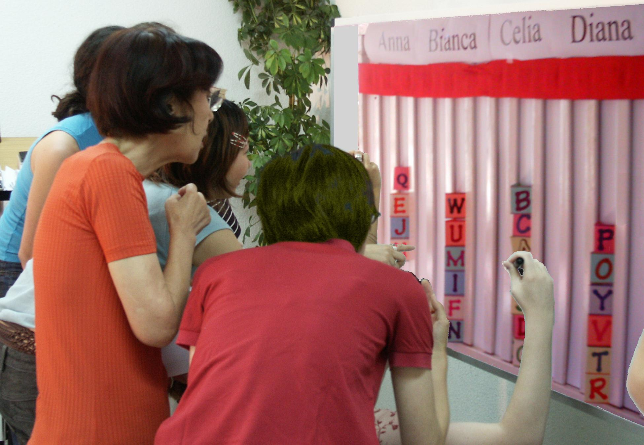  A tally board has   A card for each voter,  A column for each option,  A finish line for the favorites.
Budget Refill Votes Adjust Departments   A big department has several columns to fill.  The columns each need $100... for the dept. to  reach last year’s budget; that's its refill line.  A supporter’s cards help refill its budget columns.  Voters can push it above its refill line.  But its gain will be another department's loss.  Let's say a council of 20 decides each dept. needs  modest support from 10 voters to restore its funding.  So a column needs 10 cards from 10 voters to reach  its refill line, or 5 double cards from eager voters.  The group wants to budget 4 low-cost activities with  1 column each, plus 3 costly programs of 2 columns.  The 10 columns X 10 cards to refill each = 100 cards.  The 100 cards / 20 voters = 5 cards for a voter; that's 1 double and 3 singles. Put just 1 in a column.  Set target budgets and rank your priorities.  If a budget goes to high, its priority drops.  So move your cards to under-funded priorities.  We stop moving cards when a timer sounds.  You lose cards that are not on the board.  This deters faking votes until a last-moment switch.  A two-thirds majority may reopen the voting.
  Celia  IRV Winner |  | Diana  Runner up
  Finish Line |  | Finish Line
  B B
  J J |  | G G
  T T |  | Z Z
  K K |  | D D
  C C |  | V V

Instant Runoff Voting Elects One Winner   A finish line marks the height of half the cards+1.  That is how many votes a candidate needs to win.  Eliminate the weakest candidate if no one wins.  Draw names from a hat to break ties.  Move your card if your candidate loses.  Repeat until one candidate gets the finish line!  This chart shows four columns on a tally board.  The rule dropped Anna, so voter JJ moved.  Then Bianca lost, so BB and GG moved. |  | Pairwise Tally Centers a Policy   Flag C stands at our center, by the median voter.  Three flags surround C, about 5' from it.  We ask, "Are you closer to flag A than flag B?  If so, please raise 1 hand.” Then A against C, etc.  We put each total in the Pairwise table below.  The winner must top every rival, 1-against-1.  A pole stands at our center, by the median voters.  It holds a short Red ribbon and a long Blue one.  If the Red ribbon gets to you, the Red policy gets  your vote with its narrow appeal.  But if the Red cannot touch you, the wide appeal  of the Blue policy gets your vote. Which one wins?  If the flags are places for a heater in a cold room:  6. Do we put it at our middle or in the biggest group?  7. Do we turn on its fan to spread the heat wide?
  Anna  Eliminated 1st |  | Bianca  Eliminated 2nd
   |  | B B
  J J |  | G G
  against | A | B | C | D
  for A | — | 2 | 2 | 3
  for B | 5 | — | 2 | 3
  for C | 5 | 5 | — | 4
  for D | 4 | 4 | 3 | —
Instant Runoff Voting continued  By organizing voters, Instant Runoffs avoid:  Spoilers and the lesser-of-two-evils choice;  Costly runoffs and winners-without-mandates.  IRV elects leaders in San Francisco, Burlington...  It elects students at Duke, Rice, Reed, MIT, UCLA…  1. A card that moves is no bigger than any other: T, F  2. Your 2nd choice vote can’t hurt your 1st choice: T, F  3. Only one candidate can reach 50% + 1 vote: T, F  Single Transferable Vote Elects 3 Reps   The finish line is set at 1/4 of the cards + one.  Give no cards to a candidate who has finished.  Eliminate the weakest candidates one at a time.  Move your cards until three candidates win!  STV is used in Australian and Irish elections, at Princeton, Harvard, Berkeley, Oxford Cambridge,  in some labor unions and in the Church of England.  STV gives each group their fair share of seats.  It elects more women and political minority reps.  Voters get more choices; so more turnout to vote.  It makes more effective votes that elect reps.  4. What total fraction must three STV reps win? | Answers: IRV: T, T, T. STV: ³/₄. MMV: no. Pairwise: middle, yes. | Movable Money Votes Buy Public Goods   Let's say we each put in $1 to buy some items.  You get two 25¢ voting cards and a 50¢ card.  We say an item needs modest support from 8 of  us to prove it is a public good worth public money.  So the finish line marks the height of 8 cards.  You may put only one of your cards in a column.  So you can't dump all your cards on a private item.  Tip: Give your double card to your favorite.  This way 4 eager voters can fund a low-cost item.  A costly item must fill several columns. A column  here holds $2, so a $4 item must fill two columns.  When an item wins, the banker hides its cards. We  drop an item if it costs more than all the cards left.  Then one at a time, we drop the least popular item,  with the lowest level of cards in its columns.  Move your card from a loser to your next choice.  Tip: You may save a threatened favorite by briefly withholding your cards from lower-choice items.  We stop when all items still on the table are paid.  Only a few items can win, but all voters can win!  5. Should we let each voter or rep fund private items?

