  4 Decision Tools  in Pictures & Games |  | “This is the site for learning about democracy.”¹  “A huge contribution to the democracy cause.”²  “Congratulations on a brilliant piece of work.”     ← more endorsements on panel 67  Touch, See and Hear How  The best voting rules are fast, easy and fair. They help groups from classrooms to countries. The results are well centered and widely popular.    They strengthen the votes supporting  $ $  $ $  1    one chairperson or policy and  fair-shares of seats or $pending.  Then Act  Share this illustrated booklet with friends. Build support in your school, club or town  Enjoy better relations, politics, and policies,  panels 51, 32, and 58.

Contents, abridged edition  Three ways to learn four decision tools  I. Voting Primer tells the stories of the four tools   Errors, Eras and Progress of Democracy 2   Instant Runoff Voting Elects a Strong Leader 8   Fair Representation Elects a Balanced Council 14   Fair Share Voting Sets Many Budgets New 20   Condorcet Tally Enacts a Balanced Policy " 26  How to Try One, These Reforms Aid Others 32  II. Workshop Games let us be inside the four tallies  Leader, Reps, Budgets, Policy New 37  III. SimElection™ maps make tally patterns visible  Reps, Budgets, Policy, Council New 46  —————  IV. Social Effects of better tools between people  Consensus on a Policy, and on Budgets 55  Countries with Plurality, Runoffs, or Fair Rep 57  V. Endnotes, Endorsements, Glossary and Index 60  © CC BY-SA 4.0 2019; Robert Loring  FairVote, Takoma Park, MD |  | Two of Many Tragedies  Old ways of adding up votes fail to represent large groups in many places. In the USA, North Carolina had enough black voters to fill up two election districts. But they were a minority spread over eight districts. So for over 100 years, they won no voice in Congress. As voters, they were silenced – with tragic results.¹  The Northwest was torn apart for many years as forestry policies were reversed again and again. Hasty logging in times of weak regulation wasted resources. Sudden limits on logging bankrupted some workers and small businesses. If this policy pendulum swings far, it cuts down forests and species, families and towns.² 2  What’s Wrong?  We all know how to take a vote when there are only 2 candidates: We each vote for 1 or the other. For such a contest, the yes or no votes say enough. But as soon as 3 candidates run for 1 office, the situation becomes more complicated. Then that old yea or nay voting is no longer suitable.³ It's even worse at giving fair shares of council seats, setting many budgets, or finding a balanced policy. Our defective voting rules come from the failure to realize this:  There are different uses for voting.  and some need different types of voting.  3

In the 19th Century  Winner-Take-All Districts = Off-Center Councils    $$$ LAWS $$$  Typical Council Elected By Plurality Rule  Eras, Voting Rules and Typical Councils  Some English-speaking nations still count votes by England's old plurality rule. It elects only one rep from each district – and winning does not require a majority. It merely elects the one who gets the most yes votes.  A district with only one rep tends to develop only two big parties.⁴ It gets worse: a district's bias often makes it a “safe seat” for one party. So the voters are given either a very limited choice or no real choice. ⁵  A few who do get choices can make a council swerve from side to side. Its majority (above) sets all budget$ and policies in another battle of winner takes all.  4 |  | In the 20th Century  Fair-Share Elections = One-Sided Majorities  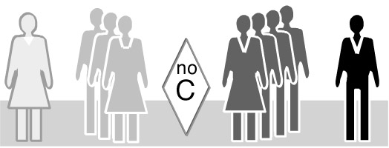  $ $ $ LAWS $ $ $  Typical Council Elected By Fair Representation  Fair Representation was developed around 1900 to end some major problems caused by plurality rule. Most democracies now use “Fair Rep”. It elects several reps from each election district. It gives a group that earns say, 20% of the votes, 20% of the council seats. Thus Fair Rep delivers fair shares of representation.⁶ It is often called Proportional Representation or PR.  It leads to broad representation of issues and views. But usually there is no central party (C above) and the two biggest parties normally refuse to work together. So the side with the most seats forms a ruling majority. Then they enact policies skewed toward their side.  5
In the 21 Century  Ensemble Councils = Balanced Majorities    $ $ $ LAWS $ $ $  Ensemble Elected By Central And Fair-Share Rules  Ensemble rules will elect most reps by Fair Representation, plus a few elected by a central rule ( C above). So the political views on the council will have a spread and a midpoint like the whole voting public.  Later pages will show how a rule can elect reps with wide support and views near the middle of the voters.⁷ So winners will be at the center of a Fair Rep council. So they’ll be the council's powerful swing votes.  Most voters in that wide base of support won’t want averaged or centrist policies. They’ll want policies to combine the best suggestions from all groups.  6 |  | Progress of Democracy  A centrist policy enacts a narrow point of view; it excludes other opinions and needs. A one-sided policy also blocks rival ideas.  A compromise policy tries to negotiate rival plans. But contrary plans forced together often work poorly. And so does the average of rival plans.  A balanced policy unites compatible ideas from all sides. This process needs advocates for diverse ideas. And more than that, it needs powerful moderators.  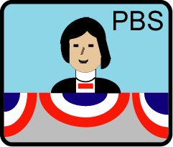  A broad, balanced majority works to enact broad, balanced policies. These tend to give the greatest chance for happiness to the greatest number of people. Their success is measured in a typical voter's education and income, freedom and safety, health and leisure.⁸  Older rules often skew results and hurt democracy.  An ensemble is inclusive, yet centered and decisive— to make the council popular, yet stable and quick. We'll see these qualities again as graphics and games show the best ways to set budgets and policies.  7

ELECTING A LEADER  Nine Voters  Let’s think about an election with nine voters whose opinions range from left to right. The figures in this picture mark the positions of voters on the political left, right or center. It is as though we asked them, “If you want high-quality public services and taxes like Sweden or Denmark, please stand here. Like Canada? Stand here please. Like the USA? Stand there. Stand over there for Mexico's low taxes and government services.”  Throughout this booklet, we're going to show political positions in this compelling graphical way.  Nine voters spread out along an issue.  High taxes buying Low taxes buying  great gov. services poor gov. services  8 |  | Plurality Election  Here we see three rivals up for election. Each voter prefers the one with the closest political position. So the voters on the left vote yes for the candidate on the left.  Ms. K is the candidate nearest four voters.  L is nearest two and M is nearest three.  Candidates L and M split the voters on the right.  Does anyone get a majority (over half)? Yes, No  Who gets the plurality (the largest number)? K, L, M  Who gets the second-largest number of votes? K, L, M  A mere plurality gives the winner a weak mandate. That is the legitimacy effective votes loan to a winner. Strong mandates are a goal of accurate democracy.  By plurality rule, the one with the most votes wins.  K is nearest four voters. M is nearest three.  L is nearest two.  9
Runoff Election  To hold a runoff, we eliminate all but the top two. Who wins the runoff here? K, M  The two (gray) who had voted for L now vote for M. Do ballots that change count more than others? Yes, No  Only four “wasted votes” fail to elect anyone.  More ballots became effective votes—a basic goal.  Did the plurality election waste more votes? Yes, No  Did this runoff give a stronger mandate? Yes, No  Runoffs almost ask, “Which side is stronger?” Later, these voters will use another voting rule to see, “Where is our center?” And a bigger group will use a rule to find out, “Which trio best represents all of us?”  In a runoff, the top two compete one against one.  Candidate M wins the runoff.  10 M wins by 5 to 4. No, each is 1 vote. Yes. Yes. |  | Politics in Two Issue Dimensions  When more issues concern the voters, a voting rule keeps its character.¹  This photo shows voters choosing positions all across two issue dimensions: left to right plus up and down. A person's position on the first issue does not help us guess their position on an independent issue.  “Please step forward for more regulation of ___. Please step back if you want less regulation.  Take more steps for more change.”  The chapter on sim games and research will show more tallies with two and even three issue dimensions.  Seventeen voters take positions on two issues:  more or less regulation □ and taxes for services   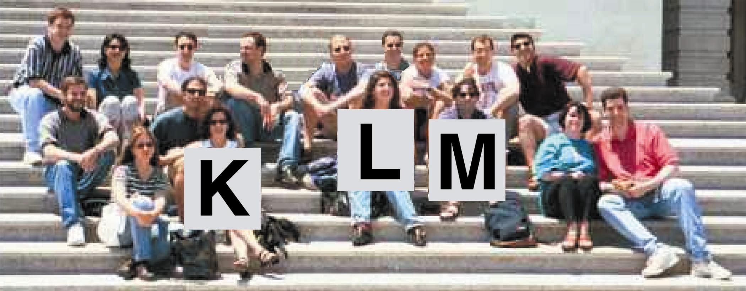  Kay wins a plurality. Em wins a runoff.  11

The goal of Instant Runoff Voting is this:  A majority winner,  from a single election.  Voting is easy. Rank your favorite as first choice, and backup choices: second, third, etc. as you like.* Your civic duty to vote is done.  Now your vote counts for your top-rank candidate. If no candidate gets a majority, the one with fewest  votes loses. So we eliminate that one from the tally. Your vote stays with your favorite if she advances.  If she has lost, then your vote counts for your backup.  This repeats until one candidate gets a majority.  Why Support Instant Runoff Voting (IRV)  Backups give you more power and freedom to express opinions with less risk of wasting a vote.  No hurting your first choice by ranking a backup, that does not count unless your first choice has lost.  No worry about vote splitting in a faction as votes for its loser(s) can count for each supporter's backup.  A majority winner from one election, so no winner with weak a mandate and no costly runoff election.  High voter turnout also creates a strong mandate; turnout often drops during a runoff election.²  Less divisive campaigns because many candidates act  nicer to get backup votes from a rival’s supporters.³  12 *Panels 31 and 39 show ballots. |  | Instant Runoff Voting Patterns  Running for president in South Korean, the former aide to a dictator faced two popular reformers. The two got a majority of the votes but split their supporters. So the aide won a plurality (37%, 28%, 27%, 8%). He claimed a mandate to continue oppressive policies. Years later he was convicted of treason in the tragic killing of pro-democracy demonstrators.⁴  A voter‘s backup is often like his favorite, but more popular. So by eliminating one reformer, IRV may well have elected the stronger one with a majority.  1 2 3 4  1) Violet loses; so backup choices get those votes. The IRV games will show more detail.  This majority mandate helps a chief executive work with reps on the biggest side of a typical council.  IRV elects leaders in more and more places: Maine, Minneapolis and San Francisco now use it; plus students at Duke, Harvard, Stanford, Rice, Tufts, MIT, Cal Tech, Carlton, Clark, Hendrix, Reed, Vassar, the Universities of CA, IA, IL, MA, MN, NC, OK, TX, VA and WA.⁵  Australian and Irish voters have used it for 100 years. They call it Preferential Vote or Alternative Vote; many in the United States call it Ranked Choice Voting. 13
ELECTING A COUNCIL  Three Single-Winner Districts  A class of 27 wants to elect a planning committee. Someone says, “Elect a rep from each seminar group.”  5 B votes elect her in the top group as only 4 vote J.  5 B 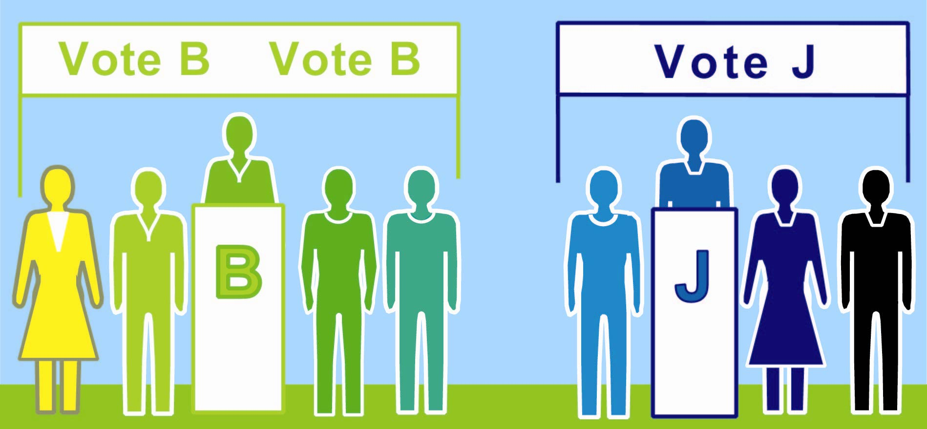 4 J  votes wasted on a loser  votes elect a rep  5 C 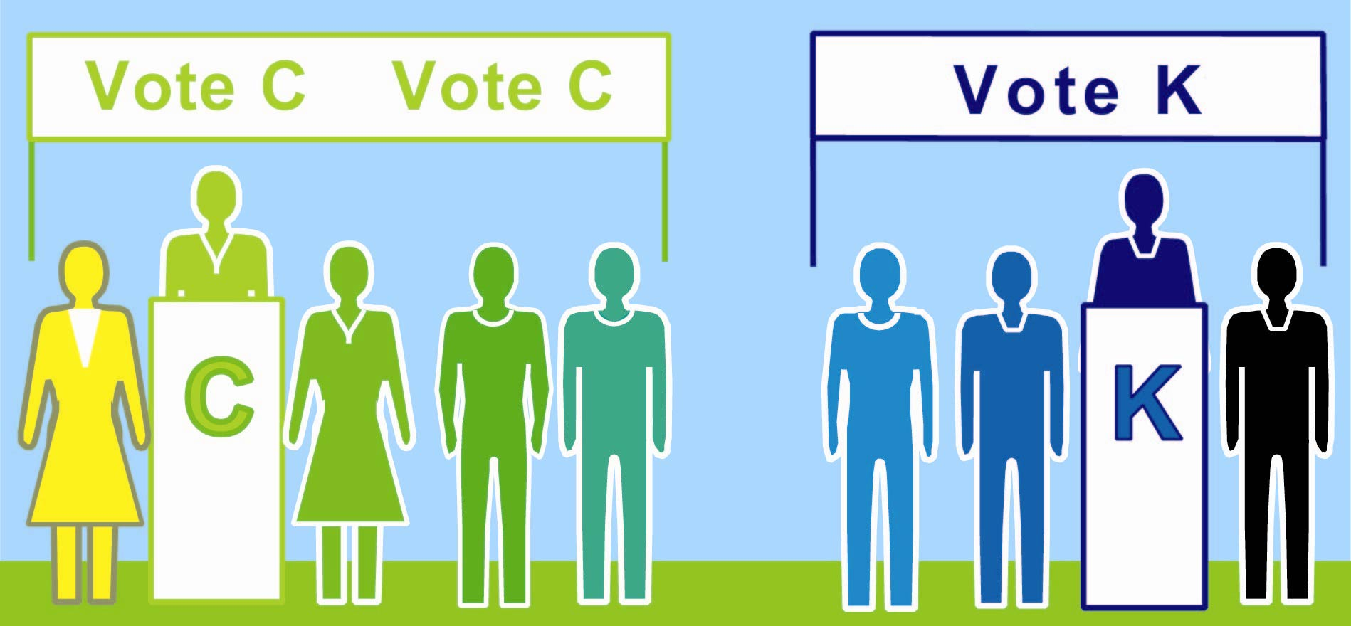 4 K  wasted  1 D 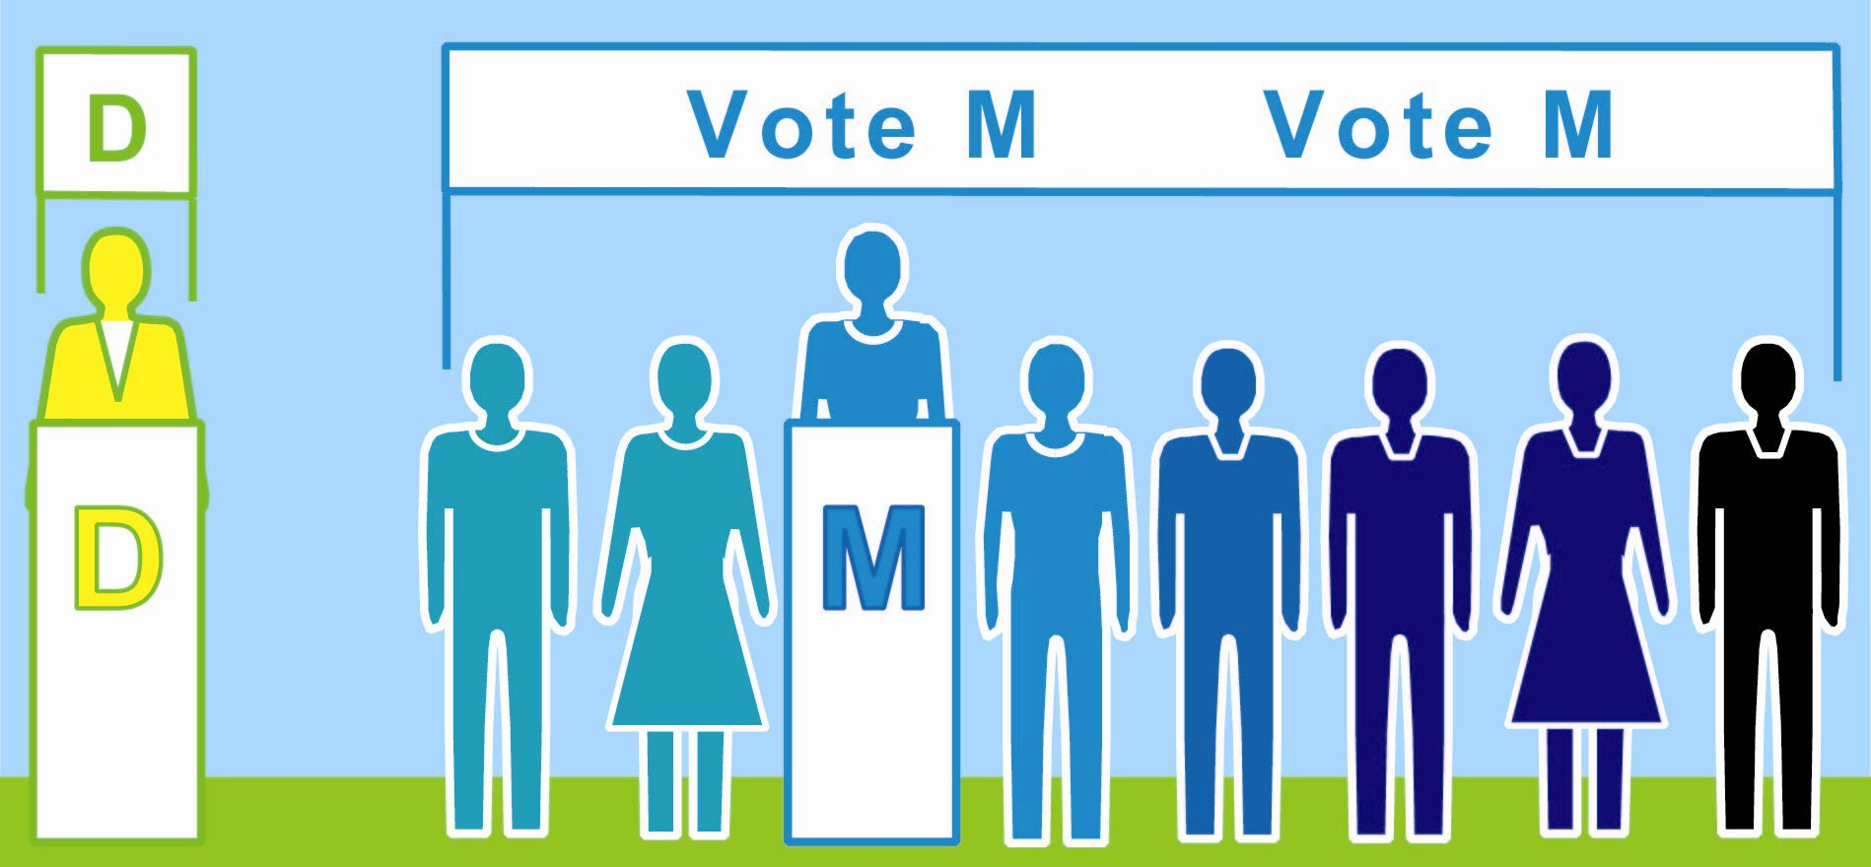 8 M  Total wasted votes  1 + 11  3 surplus votes wasted  A minority with 11 voters gets majority power with 2 reps.  14 But if it were spread out evenly, it would get none. |  | One Fair-Representation District  A better suggestion says, “Keep the class whole. Change the votes needed to win a seat from 1/2 of a small seminar to 1/4 of the whole class plus one.” So three reps need 3/4 of the votes. Wasting fewer votes gives the council a stronger mandate.   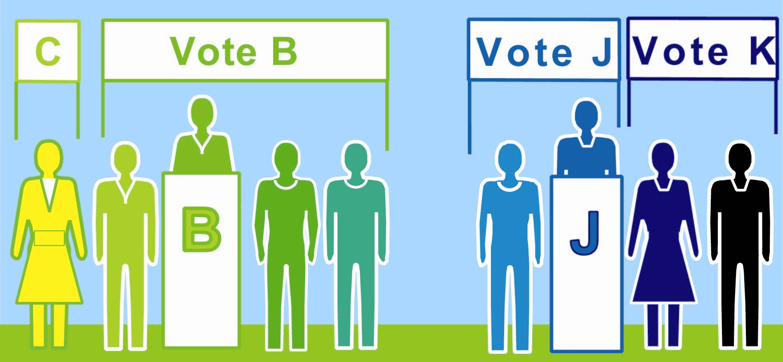 4 B 2 J    7 C 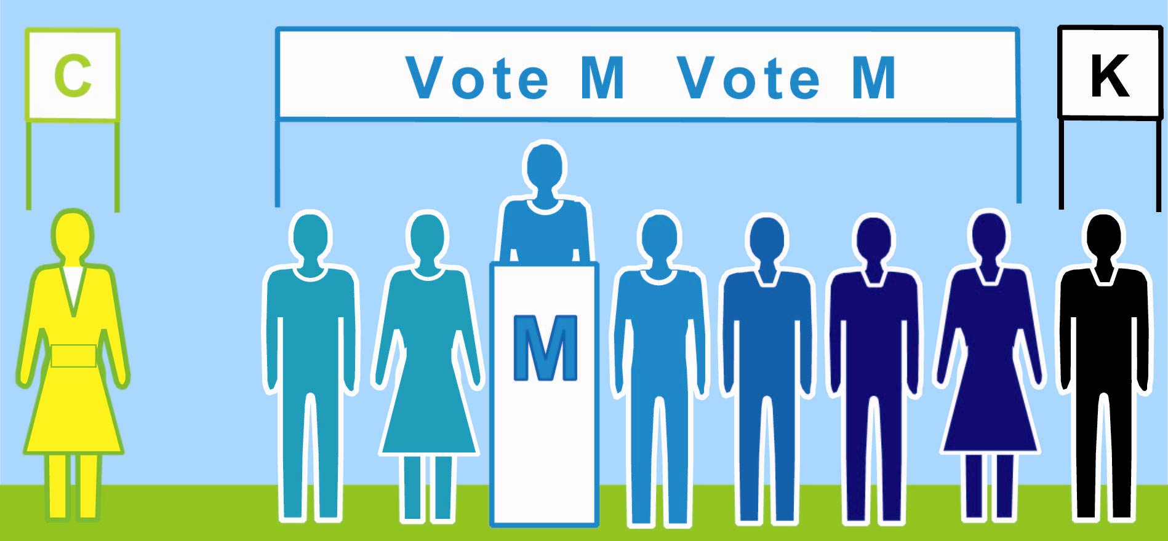 7 M 7K  Total wasted votes  4 + 2  Now a majority gets 2 reps and a minority gets 1.  Many wasted votes may expose a gerrymander. 15

The principle of Fair Representation is:  Majority rule by representing the groups in proportion to their votes.  That is, 60% of the vote gets you 60% of the seats,  not all of them. And 20% of the vote gets you 20% of  the seats, not none of them. These are fair shares.  How does it work? There are three basic features:  We elect more than one rep from an electoral district.  You vote for more than one; you vote for a list. You pick a group's list, or you list your favorites.  The more votes a list gets, the more reps it elects.  Why Support Fair Representation (Fair Rep)  Fair shares of reps go to the competing groups so Diverse candidates get a real chance of winning so Voters have real choices and effective votes so  Voter turnout is strong.¹  Women win two or three times more often² so  Accurate majorities win—also due to real choices,  high turnout, effective votes and equal votes per rep so Policies match public opinion better.³  It’s more fair, for a more ethical organization.  16 This is often called Proportional Representation. |  | Fair-Shares and Moderates  Chicago elects no Republicans to the State Congress, even though they win up to a third of the city's votes. But for over a century it elected reps from both parties. The state used a fair rule to elect 3 reps in each district. Most gave the majority party 2 reps and the minority 1; so both parties courted voters in all districts.  Those Chicago Republicans were often moderates. So were Democratic reps from Republican strongholds. Even the biggest party in a district tended to elect more independent-minded reps..So they could work together and make moderate policies.⁴    ✓ Shares of votes equal fair shares of seats.  New Zealand switched in 1996 from single-member Districts to a layer of SMDs within Fair Representation. This is called Mixed-Member Proportional or MMP. A small, one-seat district focuses more on local issues. Fair Rep frees us to elect reps with widespread appeal.  The seats won by women rose from 21% to 29%. The native Maoris reps increased from 7% to 16%, which is almost proportional to the Maori population. Voters also elected 3 Polynesian reps and 1 Asian rep.⁵  17
Why It Elects More Women  New Zealand and Germany elect half of their MPs in single-member districts and half from Fair Rep lists.  The SMDs elect few women; but in the same election, the party lists elect two or three times more women.  In every one-seat district, a party's safest nominee is likely to be a member of the dominant sex, race, etc. That adds up to very poor representation of all others.  Fair Rep leads a party to nominate a balanced team of candidates to attract voters. This promotes women.⁶ A team can have class, ethnic and religious diversity. And that gives us diverse reps to approach for help.  more: competition, real choices, voter turnout, effective votes, stronger mandates, diverse reps, women reps, popular policies  Some leading women spoke of starting a new party in Sweden, which uses Fair Rep. Under plurality rule, a big new party splits their own side, so it loses. But Fair Rep gives every big party its share of seats.  This credible threat made some parties decide that job experience was not as important as gender balance. So they dropped some experienced men to make more room for women on the party list. And they won.⁷ Now they are incumbents with experience, power and allies.  18 |  | Voting Rules and Policy Results  SMDs elect reps with a wide range of vote totals. So a majority of reps might not represent most voters. Fair Rep and MMP require more equal votes per rep. So each majority of reps does stand for most voters, producing policies closer to public opinion.²  Many voters see a woman in a multi-winner race less as fighting her rivals, more as supporting her issues.  less: gerrymandered districts,  wasted votes, monopoly politics,  dubious democracy  Councils with fewer women tend to do less for health care, childcare, education and other social needs.⁸ Then the poorest schools and clinics are a blight, as are the citizens and workers hurt by poor education or health.  If such urgent needs overwhelm us, we neglect the  essential need to reform their structural source:  We often get poor results from poor policies, due to  poor representation largely due to poor voting rules.  The countries with the best voting rules give the best quality of life, as measured in the scores on page 58. We would all like better quality-of-life results for our country, and for our towns, schools, clubs and co-ops.  So help friends talk about and try these voting rules.  The Fair Rep games and sims will show more. 19

SETTING THE BUDGETS  Fair Shares to Buy Shared Goods  Electing reps is the most obvious use of voting rules. Rules to set policies and budgets are also important. These decisions occur more often than elections and occur even in groups that don’t hold elections.  Fair Representation distributes council seats fairly. Voting can also distribute some spending power fairly.  Democratic rights progress: Each step makes a democracy more fair, thus accurate, popular and strong:  ✓ Voting for rich men, poor men, colored men, women.  Fair Representation for big minority parties.  Fair Share Voting by big groups of voters or reps.  Counties, co-ops and colleges  can gain by Fair Share Voting  $ $ $ $ LAW $ $ $ $ $  All big groups have a right to allocate some funds. |  | Patterns of Unfair Spending  Participatory Budgeting: PB lets neighbors research,  discuss and vote how to spend part of a city's budget. It is a big step up for democracy. In South America, it spread from one city in 1989 to several hundred today. The World Bank reports that PB tends to raise a city’s health and education while cutting corruption.¹  In 2010, a Chicago alderman gave $1,300,000 to PB.² But a plurality rule made the votes and voters unequal. Each vote for the park won $501. (its price / its votes) But if given to fund the bike racks, each won only $31. That's too unfair. Even worse, more than half the votes were wasted on losers.³  A costly winner makes many  lose.    A bad election rule gets worse when setting budgets. It is not cost aware, so it often funds a very costly item and cuts a bunch that get many more votes per dollar. To win this bad tally, load various proposals into one. Keep raising its cost if that attracts more votes.  One year, a scholarship fund got many surplus votes. These were wasted votes because they had no effect. So the next year, many supporters chose not to waste a vote on this “sure winner.” It lost! They saw the need for a voting rule that would not waste surplus votes.⁴ 21
The principle of Fair Share Voting is:  Spending power for all,  equal to their share of the votes.  That is, 60% of the voters spend 60% of the money, not all of it. A project needs grants offered by many voters to prove it is a common good worth group funds. So a voter’s grant is a small share of a project’s price.  Voting is easy. Simply rank your choices, like in IRV. Your civic duty to vote is done.  Then your ballot offers a grant to each of your top choices—as many as it can afford. A tally of all the ballots drops the project with the fewest offers. This repeats until it drops or fully funds each project.³  Some Merits of Fair Share Voting (FSV)  FSV is fair to a project of any price, and to its voters It takes a costly offer to vote for a costly project so A ballot's money can help more low-cost projects.  This motivates a voter to give his top ranks to the projects he feels give the most joy per dollar.  Votes can move from losers to backup choices so Voters split by similar proposals can unite on one And the set of winners gets stronger support,  22 because the ballots leave few wasted votes. |  | Fair Share Voting Works This Way  If a majority controls all the money, the last item they choose adds little to their happiness; it is a low priority. But that money can buy a high priority of another big interest group, adding more to their happiness.  In economic terms: The social utility of the money and winners tends to rise if we each allocate a share. Fair share, cost-aware voting gives more voters more of what they want for the same cost = more satisfied voters. Shares also spread good opportunities and incentives.  In political terms: The total spending has a wider base of support: It appeals to more voters because more see their high priorities get funding.  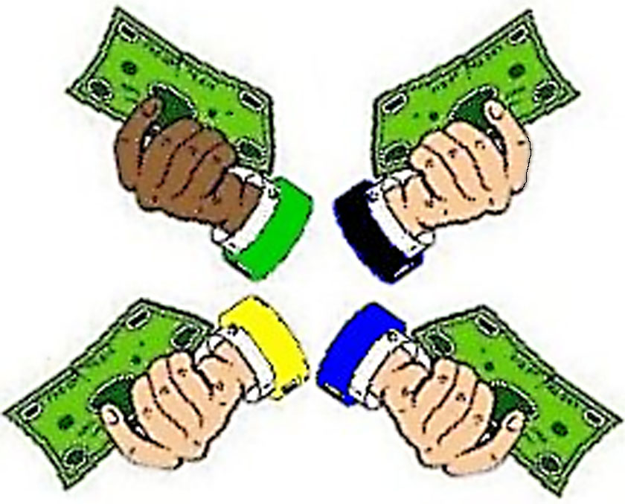  ✓ ✓  ✓ ✓  ✓ Fair shares spread the joy and opportunities.  Plurality rules let surplus votes waste a big group’s power and let rival budgets split it, as seen on page 14. The biggest groups may have the biggest risks.  FSV protects the majority right to spend a majority of the money by eliminating split votes, as did IRV, and surplus votes, as we’ll soon see. 23

Adjusting Budgets, optional  You may write-in and rank budget levels for an item. Your ballot may pay only one share of a budget level. Often, it can afford to help many of your favorite items.  A budget level needs to get a base number of votes. It gets a vote when a ballot offers to share the cost up to that level or higher. cost / base = 1 offer = 1 vote.  If more ballots divide the cost, each of them offers less.⁶ You only pay up to a level you voted for and can afford.  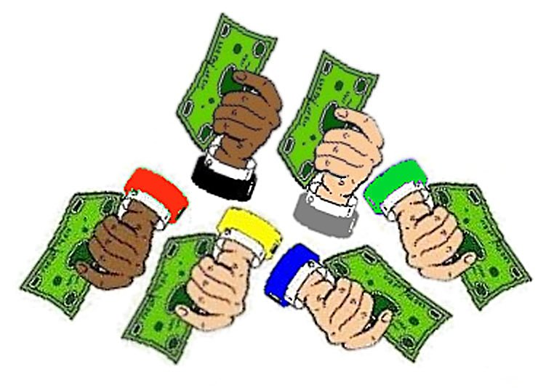  The item with the weakest top level, loses that level. Any money you offered to it moves down your ballot to your highest ranks that lack your support. This repeats until the top level of each item is fully funded by its own supporters.  A large base of support must  agree, this item is a high  priority for our money.  A group of 100 set out base number at 25 votes.⁷ My first choice got just enough voters, so my ballot paid 4% of the cost. 100% / 25 votes = 4%.  My second choice lost; did it waste any of my power?  My third choice got 50 votes, so my ballot paid only 2% of the cost. Were there any surplus? Did I waste much power by voting for this sure winner?  24 None. None. Not much. |  | More Merits of Fair Share Voting   After discussion, one poll quickly sets many budgets. It reduces agenda effects such as leaving no money for the last items or going into debt for them.  It lets sub-groups pick projects; so it’s like federalism but without new layers of laws, taxes and bureaucracy. And it funds a big group even if they're scattered.  Each big group controls only its share of the money.  This reduces their means and motives for fighting.  Fairness builds trust in spending by subgroups and can raise support for more. This can cut spending at the extremes of individual and central control.  N€w N¥w  New Tool  N₤w N$w  Merits of FSV for an Elected Council  FSV gives some power to reps in the opposition so Electing them is more effective, less of a wasted vote.  They ease starvation budgets that damage programs. This makes program management more efficient.  A voter can see grants by his rep to each program, tax cut or debt reduction and hold her accountable.  The FSV games will let us eat the winners! 25
ENACTING A POLICY  Condorcet Test Number Two  The Runoff on panel 10 is a one-against-one contest between the positions of candidates M and K. Five voters like M's position better than K's.  Here is a second test with the same voters. K loses this one-against-one test. L wins by five votes to four.  Each person votes once with a ranked choice ballot. Panels 31 and 43 show two kinds of ballots. A workshop page shows a Condorcet tally table. And the sim maps show Condorcet voters with more issue dimensions.  People often struggle to find  a group’s center of opinion  K is nearest four voters. L is nearest five voters.  26 |  | Condorcet Test Number Three  Candidate L wins her next one-on-one test also. She even got one “surplus vote” more than needed.  She has won majorities against each of her rivals. So her position is the “Condorcet winner”.  Could another person top candidate L? Yes, No  Hint: Is anyone closer to the political center? Yes, No  Who is the Condorcet winner on panel 11? K, L, M  Thus a Condorcet Tally picks a central winner.  It can elect a moderator to a council. panel 6 But is it likely to elect diverse reps? Yes, No  It can set the 'base of support' in FSV. panel 24  But is it likely to spread spending fairly? Yes, No  L has six votes. M has three.  Yes. Yes. L. No. No. 27

The goal in a Condorcet Tally is this:  Majority victories,  over every single rival.  The winner must top every rival, one-against-one.  The sports analogy is a “round-robin tournament.” A player has one contest with each rival.  If she wins all her tests, she wins the tournament.  Each voting test sorts all of the ballots into two piles.  If you rank option J higher than D, your ballot goes to J.  The one that gets the most ballots wins this test.  If one wins all its tests, it wins the Condorcet Tally.  (If none does, IRV can elect one of the near winners.¹)  Why Use Condorcet Tallies (CT)  No split-vote worries as duplicates don't help or hurt each other.¹ The ad hoc majority ranks all of their favorites over other motions. Their top one wins.  Ranked choice ballots poll related motions all at once, simplify the old rules of order and speed up voting. They reduce agenda effects, from simple errors to free-rider and wrecking amendments. panel 67  A balanced process tends to be stable, thus decisive. Yet, a balanced process can calm some fears about reviewing and changing a good policy to improve it.  28 All this saves money and builds respect for leaders. |  | Policies with Wider Appeal  A plurality or runoff winner gets no votes from the losing sides and doesn't need to please those voters. But a CT candidate seeks support from all sides, because every voter can rank it against its close rivals. Thus every voter is “obtainable” and valuable.  The Condorcet Tally winner is central and popular.² Most voters of the center and right like it more than each leftist policy. At the same time, most voters of the center and left like it more than a rightist policy. All sides can join to beat a narrowly centrist policy.  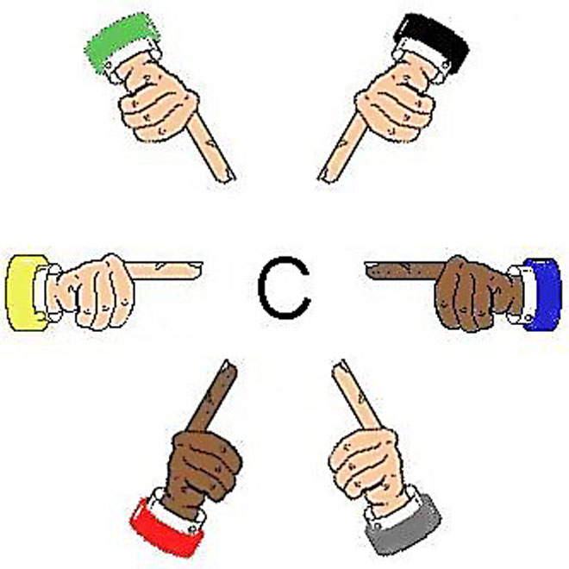  “Our center  is near me.” ✓Where  is  our  “I am the center?  center!"  Chairs with Balanced Support  CT elects a central chairperson and vice chair to hold the powerful swing votes in an Ensemble Council. They must compete for good ranks from all voters, as panel 50 will picture. So they have strong incentives to balance a council's process and policies.  IRV has slightly different effects, incentives and uses.³ Games will let us step into each tally to see some effects.  29
Resist Rigged Votes  By plurality rule, candidate M lost on panel 9. Let's say her party gerrymanders the borders of her district. They add voters (pictured in purple) who tend to like her party and exclude some who don’t. In this safe seat, bluish voters can elect M or an even a less central candidate who might polarize the council.³  But did this gerrymander change the CT winner, L?  3 rank K>L>M. 2 rank L>M>K. 4 rank M>L>K.  To steal a CT or IRV seat, my ads, trolls and news stories must mislead a majority, not just a plurality. And gifts to the other side’s "spoilers" fail to divide it.  Manipulations of plurality rules are, sadly, not rare. And point voting begs for extreme high and low votes. But a chance to manipulate IRV (or Condorcet/IRV) is rare, risky and hard.^{1, 2} So you don’t need to worry about your own or other voters’ strategies.  30 No change; L still wins the Condorcet Tally. |  | Unstack the Agenda  Some meetings concoct a policy by a series of yes-no choices, with or without rules of order, agendas or votes. An early proposal may have to beat each later one. An early decision may block some later proposals. So “stacking the agenda” can help or hurt some options.  Other meetings discuss rival options all at once; yet many people don't express their backup choices. So similar options split supporters and hurt each other. Then a minority pushing one option may seem to be the strongest group. Even sadder, a person with a well-balanced option but few eager supporters might drop it.  Too often a committee chooses all the parts in a bill. Other voters get to say only yes or no to a big bundle. Rigged votes often build bad policy and animosity. To reduce these risks, let the voters rank more options.⁵  Issue #1 Ballot  Rank Option  5 Continue Discussion  2 Original Bill, the main motion  1 Bill with Amendment 1 (a free rider?)  8 Bill with Amend. 2 (a wrecking amend.?)  7 Bill with Amendments 1 and 2  3 Postpone for 7 days  4 Refer the Bill to a Committee  6 No Change in the status quo  An ‘Incidental Motion’ does not wait for the ballot. 31

II. Workshop Games  Get your hands on 4 great voting rules.  See fair-share tallies organize voters.  Vote fast on reps, budgets and policies.  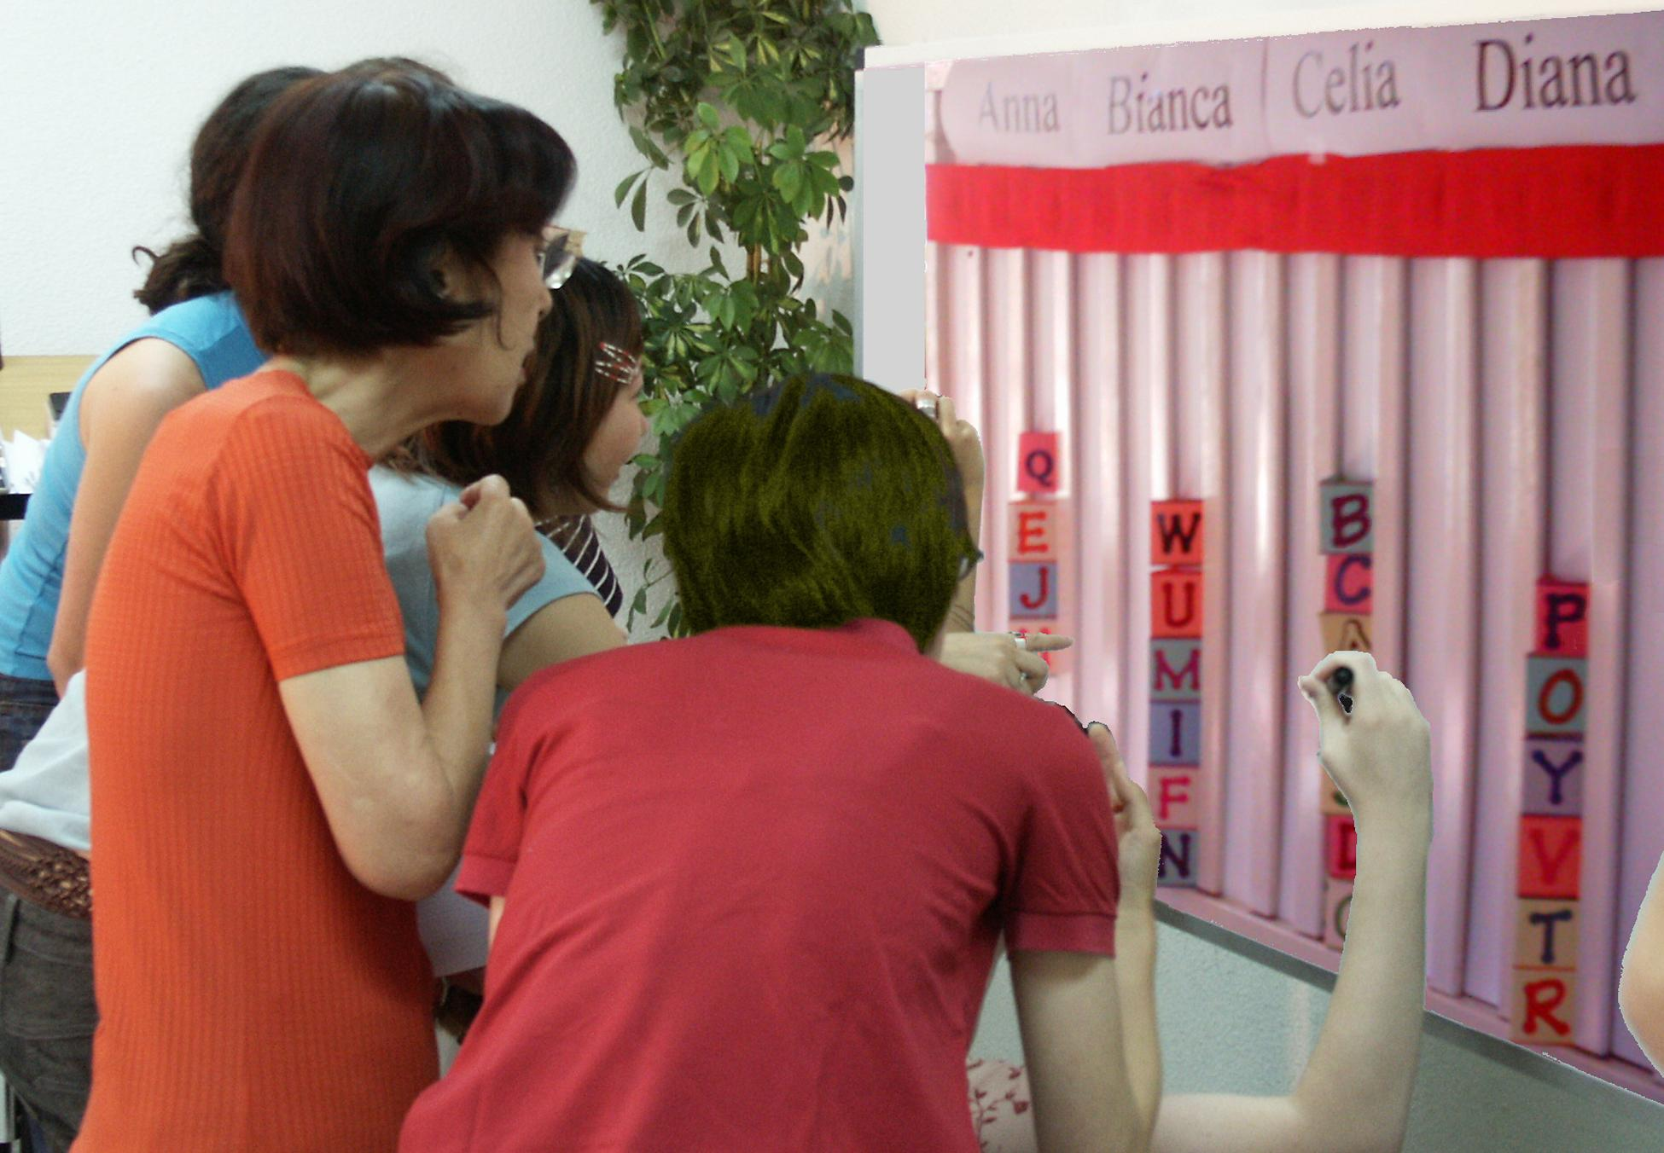  A Tally Board has  A card for each voter,  A column for each option,  A finish line for the favorites. 37 |  | IRV elects leaders in San Francisco, Minneapolis...  It elects students at Duke, Rice, Reed, MIT, UCLA…  1. A card that moves counts just like others: T, F  2. Ranking your 2nd choice can’t hurt your 1st: T, F  3. Only one candidate can reach 50% + a vote: T, F  Ask questions one and two with each voting rule.  Fair Rep by Single Transferable Vote  A tabletop tally to elect three reps works like STV.   The finish line is set at 1/4 of the cards plus one.  Don't put your card in a column that is full.  Drop the weakest candidates one at a time.  Move the cards until three candidates win!  Users include Australian and Irish voters, Cambridge, Harvard, MIT, Princeton, Oberlin, Oxford, UC Berkeley, UC Davis, UCSB, Vassar, and the Church of England.  Some of their ballots look like those on panels 31 or 43.  3. What total percentage must the three reps win?  4. Only three candidates can win 25% + 1 vote: T, F  Ranked Choice Voting includes IRV, STV, and FSV.  Transparent, fair-share budget rules New! ➔  40
Instant Runoff Voting Elects One  Tabletop tallies make Ranked Choice Voting lively.  A finish line marks the height of half the cards + 1.  That is how many votes a candidate needs to win.  If no one wins, eliminate the weakest candidate.  Draw names from a hat to break ties.  If your favorite loses, move your Post-it, card or token. Give it to your next backup choice.  Repeat until one candidate reaches the finish line!  This chart shows four columns on a tally board.  The rule dropped Anna, so voter JJ moved his card.  Then Bianca lost, so BB and GG moved their cards. | 38
  Anna  Eliminated 1st |  | Bianca  Dropped 2nd
   |  | B B
  J J |  | G G
  Celia  IRV Winner |  | Diana  Runner up
  _ Finish Line__Finish Line__Finish Line_
  B B
  J J |  | G G
  M M |  | Z Z
  L L |  | D D
  C C |  | V V

Fair Share Voting Picks Goods   We each get four 50¢ voting cards to buy treats.  We decided an item needs modest support from 8 of us to prove it is a shared good worth shared money. So the finish line marks the height of 8 cards, and  You may put only one of your cards in a column.  A costly item must fill several columns. A column here holds $4, so an $8 item must fill 2 columns.  (Version B gives you two 50¢ cards, plus a tall $1 card. The tall cards let four eager voters fund a $4 item.)  When an item wins, the treasurer hides its cards. We drop any that cost more than all the cards left.  Then we drop the one furthest from winning, with the smallest fraction of its columns filled.  Move your card(s) from a loser to your next choice. (We could let you help a weak favorite by briefly withholding your cards from your lower-choices.)  We stop when all items still on the board are paid. Only a few items can win, but all voters can win!  If your favorite is about to lose, consider briefly taking your cards off some of your lower choices so 1 of them might lose first—if your group allows this extra step. 37 | $  $  $ | …and Sets Their Budgets  A budget level needs enough cards to pay its cost. So a $4 bottle of OJ needs its voters to fill one column and the $8 size needs them to fill one more column.  Voters who want only the $8 size may fill that column first. But if the $4 column loses, so does the $8.  One at a time, the weakest levels lose and voters move their cards to help treats still on the table. Soon, all remaining budget levels will be fully funded.  A tricky agenda with several similar favorites can split an interest group so they lose by plurality rule. FSV avoids such scams and lets favorites win!  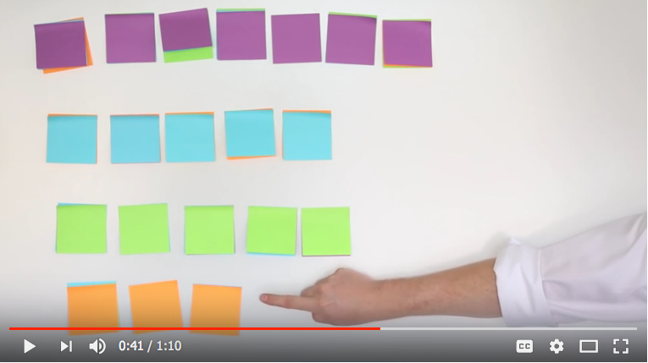  6. Should we let each member fund private items?  7. Should a member who pays more taxes or dues get more power to spend the group's money?  8. Should voters see grants by a rep? (or a voter?)  9. Who could use Fair Share Voting? IRV? STV? 38
Today’s hottest reforms are Ranked Choice Voting,
Participatory Budgeting and Fair Share Voting.
Condorcet Centers a Policy   The winner must top each rival, one-against-one.  Put flag C at our center, by the median voter.  Make 3 flags surround C, each about 5' from it.  We ask: “Are you closer to flag A than to flag B?  If so, please raise a hand.” Then test A vs C, etc.  Put each total in this Condorcet pairwise table.  Nine voters finding C tops all rivals.  Flag C has a 3' Red ribbon and a long Blue one.  If the Red ribbon gets to you, the Red policy gets  your vote with its narrow appeal.  If the Red cannot touch you, the wide appeal  of the Blue policy gets your vote. Which one wins?  If the flags are places for a heater in an icy cold room  10. Do we put it at our center or in the biggest group?  11. Do we turn on its fan to spread the heat wide?  44 |  | Workshop Suggestions  A hands-on game for loot to share makes memories more vivid and lasting than a lecture or homework.  We can vote for a party menu, a dance play list, a ... Caution: long ballots lead some voters to give up. Smart ballot design cuts voter errors and exhaustion.  Accuratedemocracy.com/a_workshop.htm has more complete answers; so does /a_primer.htm.  Visit /a_teach.htm for handouts, ballots and voting cards.  Eat the winners! while discussing how FSV helps a group pick: projects, news blogs, investments or __. Plan a real poll for the central majority or fair shares.  What qualities do you want in this poll? (next panel)  Answers and Essays  IRV 1 True, in each round of counting it is 1 vote. 2 True, doesn't count until the 1st has lost. 3 True.  STV 4 3/4 + 3 votes. 5 True, more would need >100%.  Fair Share Voting 6 No. 7 No. 8 Yes (no). 9 Many.  Condorcet 10 Center of all voters, 11 Probably yes. 45
  against | A | B | C | D
  for A | — | 2 | 4 | 4
  for B | 7 | — | 3 | 4
  for C | 5 | 6 | — | 5
  for D | 5 | 5 | 4 | —

Reviewing Some Big Benefits  Accurate Elections panel  Make voting easy, free of worry over strategies 12, 30  and much more often effective. 15, 55  Cut wasted votes to strengthen mandates. 9-15, 55  Weaken spoilers and gerrymanders. 12, 14, 30  Reduce attack ads and anger among voters. 12  Cut the payoffs to the big campaign donors. 30, 56  Give voters real choices of likely winners, by 14  electing fair shares of reps from all big groups. 18  That supports a wide range of candidates, 16  debate of issues and turnout of voters. 59  Accurate Legislation panel  Give fair representation to all big groups, so 16  the council enacts laws with real majorities. 19  Elect a central chair whose swing vote pulls 29  reps from many factions to moderate policies. 6. 48  Give members Fair Share Voting for optional 20  budgets. Let voters see each rep's spending. 25  Cut agenda effects and scams; 25, 28, 31, 38, 52  Speed-rank more options at once. 25, 31, 39  Our Web pages detail these benefits and more.  Now voting games will show the simple steps in a tally.  36 And free software on the web makes tallies easy |  | Ranked Choice Ballots  A simple tally board can serve about thirty voters. Big groups use paper ballots, or screens and printouts, then tally on computer. Risk-limiting audits need well- protected paper ballots to catch frauds and errors²  ☒ Yes-or-no ballots badly oversimplify most issues. They often highlight only two factions: “us versus them.” They tend to polarize and harden conflicts.  O Ranked choice ballots reduce those problems. They let you rank your 1st choice, 2nd choice, 3rd etc. Ranks can reveal a great variety of opinions. Surveys find most voters like the power to rank candidates.³  Party Menu Fill only one “O” on each line.  Best Ranks Worst  Treats Ballot #2 1st 2nd 3rd 4th 5th 6th  1 Fruit & Nut Platter  O O O O O  12 Chocolate Brownies O O O O O O  12 Choc. Chip Cookies O O O O O O  4 Choc. Fudge FroYos O O O O O O  1 Choc. Cheesecake O O O O O O  6 Choc. Mousse Hearts O O O O O O  Which wins a plurality? Hints: 5 chocolates vs. 1 nut.  And the first name on a ballot gets a 2 - 9% boost.⁴  Caution: long ballots lead some voters to give up.¹  Smart ballot design cuts voter errors and exhaustion. 43
III. Sim Examples  Compare Three Councils  SimElection™ made these election maps. The small shapes are voters; the big heads are candidates.  1. An Ensemble Rule is the best way to represent the center and all sides, as shown on panel 6. In the map on the next panel, Condorcet elects Al and then STV elects Bev, Di, Fred and Joe. Each winner’s name is in bold.    2. A Condorcet Series elects the five closest to the central voter: Al, Bev, GG, Joe and Fred. There is no rep from the lower right, so the council cannot balance around the central voter. Each name is in italic.        3. The STV reps? Bev, Di, Fred, GG and Joe.  Each name is underlined. STV eliminated Al!  Surprises  1. Perhaps it's surprising that broad Fair Rep helps a central Condorcet winner own a council's swing vote. It shows that political diversity can be a source of balance and moderation as well as perspective.  2. Central reps can lead a broad Fair Rep council to broader majorities, including moderates from all sides. This can add to or replace some of the “checks and balances” often used to moderate a council's action. 52 |  | Well Centered and Balanced  Only the Ensemble council has  the breadth and balance of Fair Representation with the centering of Condorcet.  File Edit Window Organize Fund Campaign  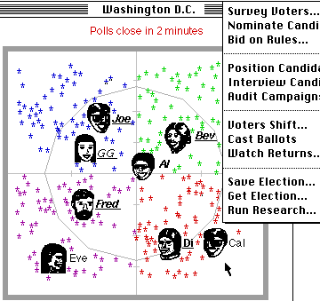  STV works to elect a balanced council with moderates, and often a centrist. But it does not push any rep to please a central majority of voters. Condorcet does →  53
Watch Condorcet Find the Center  This map puts a line halfway between Al and a rival. Voters on Al’s side of a line are closer to her; so they rank her higher than the rival. For example, the long line has more voters on Al’s side than on Joe’s. So Al wins that 1-on-1 test. She wins a very different majority over each rival here. To do that, her political positions must be central and have widespread support. panel 29  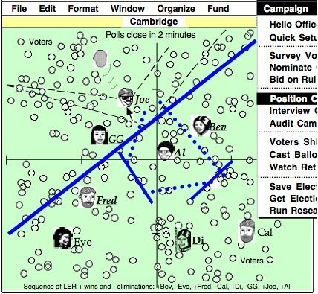  In contrast, STV and IRV require the most intense support,  first-rank votes, to avoid early elimination. IRV does too, with a high finish line of 50% + 1 vote. 54 |  | Tools Between People  A group’s decision rules pull its culture toward fair shares, or winner takes all with central or one-sided and widespread or narrow support. Less formal decisions among members often follow their group’s model.  Fair rules make cooperation safer, faster and easier. This favors people and groups who tend to cooperate, and can lead others to cooperate more often.  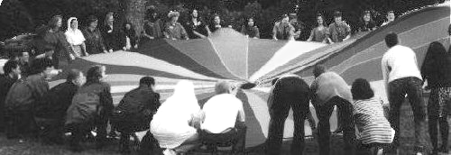  Politics are more principled and peaceful when all the rules help us find fair shares and central majorities. This may reduce political fears within our community, helping us to be more receptive, creative and free.  So better rules can help us build better decisions, plus better relationships. Both can please most people. Fair rules won’t please some who get money or self-esteem from war-like politics. But countries with fair rules tend to rank higher in social trust and happiness.¹ Voting is an exemplary tool between people. 51
Consensus and Voting  Group decision-making has two connected parts. Its discussion process may have an agenda, facilitator and proposals, plus questions and changes on each proposal. Its decision process asks the members which proposals have enough support to be winners.²  Voting only yes or no leads us to discuss and decide one formal “motion” at a time in a very strict sequence. It stifles the sharing of ideas and development of plans. But both consensus and ranked choice ballots let us discuss and decide all closely-related options together.  Discussing an issue well often resolves most parts, with mandates up to 100%. Yet we may want to decide some parts with the best voting rules. Why?  Why Take a Vote  The best rules strengthen some reasons for voting:  Choice ballots let us speedup meetings. panels 25, 31  Secret ballots reduce social pressure and coercion.  A well-designed ballot and tally promote equality: Even busy or unassertive people can cast full votes.  The best rules weaken some reasons to avoid voting:  A Condorcet Tally, is less divisive. panels 12, 43  It rewards blending compatible ideas. panels 29, 50  So more members help implement a decision.  52 |  | Complementing Consensus  Groups that seek consensus on basic agreements may vote on other issues, such as choosing a minor detail like a paint color or funding a few optional projects.  Fair Share Voting can give fair shares of power. Inclusive yet fast, it won't let one person block action. Cooperative, not consensual or adversarial, it is less about blocking rivals, more about attracting allies. Its ballot guides a voter to limit and prioritize budgets. Its tally weighs dozens of desires, of varied cost and priority, from dozens of overlapping groups. We may modify our FSV results through our usual process.  All majorities prefer the Condorcet winner.  A proposal needs to top each rival by 50% plus one; and we may require it to win 60% or even 100% over the status quo on issues that involve our basic agreements. So 41%, or even one voter, may block a Condorcet winner by writing-in a basic concern about it.  Carpentry Analogy  The nice consensus methods are like nice hand tools, and these nice voting methods are like nice power tools. The power tools speed cutting through piles of boards or issues and cutting through a hardened board or issue. The high-touch tools help us discover and develop insights and options with additional benefits.³  So most of us want both kinds of tools. 53

How to Try One  It's easy to test-drive a new rule in a survey. Or a council can form a “committee of the whole” to vote, tally and report results to enact by old yes-or-no rules.  Many groups adopt a book of parliamentary rules, then amend it with their own “special rules of order” to make their decisions more popular, stable and quick.¹  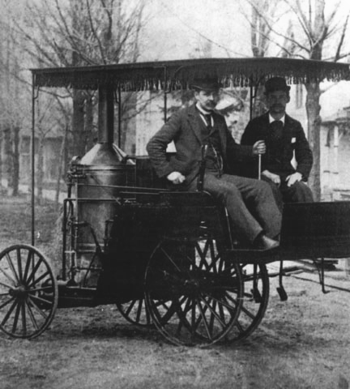  Steering Analogy  When choosing a voting rule, a new Mercedes costs little more than an old jalopy. That price is a bargain when the votes steer important budgets or policies.  Does your car have an 1890 steering tiller or a new, power steering wheel? Does your organization have an 1890 voting rule or a new, centrally balanced rule?  Today's drivers need the skill to use power steering, but they don't need the math or logic to engineer it. Same with voters and voting rules. 54 |  | Voting Reform Is Cost Effective  Issue campaigns lobby reps every week for years.  This eases one problem, but rarely fixes the source.  Election campaigns cost a lot all at once. The biggest faction can skew all policies for a few years.  Reform campaigns cost no more than elections.  A win strengthens reps and policies for many years.  Issue  Election  Reform  2018 2020 2022 2024  Campaign costs in gray, results in yellow.  Strengthen Votes and Mandates  Better voting rules expand the base of power,  the number of effective votes required to support: Pages  a CEO or a Chair from a plurality to a majority 13, 29  a Council from a plurality to over three quarters 15  a Budget from a few power blocs to all members 22  a Policy from a one-sided to an over-all majority. 28  Votes for real choices tally up democratic power. It needs new strength to balance growing powers of  military, money and media. The stronger mandates empower action to achieve widely-shared goals. 55
These Reforms Aid Others  A news firm might inform us better if it is ruled by voting subscribers, more than investors or advertisers. VoterMedia.org has low-cost tools for any group, e.g. use FSV votes to reward the best local-news bloggers.  Public campaign funding in Maine and Arizona lets reps give less time to big sponsors and more to voters. One plan gives each voter $50 of vouchers to donate.³ Such nameless gifts or FSV may cut corrupt paybacks. Big sponsors aim $ to buy the few swing-seat SMDs. That's harder for them under IRV or Fair Rep.⁴  “It’s very hard to see us fixing the climate until we fix our democracy.” –Dr. James Hansen⁷  Ballot access laws make it hard for small parties to get on the ballot — because big parties fear “spoilers”. Good voting rules such as IRV can calm that fear.  Sabbatical terms make the current rep run against a former rep returning from rest, reflection, and research. It’s a choice between two winners with actual records. Good rules do not hurt a party with extra nominees.  Citizens’ assemblies⁹ and their referendums can get more choices and control by using Condorcet Tallies. The laws on voting rules, reps’ pay, $ponsors, etc. need referendums because the reps have conflicts of interest.  56 Good schools, taxes and voting may go together.⁸ |  | Civil Society Builds Democracy  Merchants and workers in medieval guilds won  some rights by building group skills, unity and allies. Now town councils, co-ops and schools can build skills.  Critical, skeptical, empirical thinking¹⁰ from the Age of Enlightenment led to revolutions for human rights. Now rights can include Fair Rep and Fair Share Voting.  A big need for workers has often raised their pay and political strength, thus the political equality of society. Now more progressive taxes¹³ can help political equality.    Move to a more democractic place (or .org)  To get good policies quickly, go where they are used. For example, do you want the democratic control and long-term savings of county or co-op owned utilities?¹¹  CEOs need to be assertive, but not authoritarian¹² which corrupts commerce, democracy and human rights. How can voting tools fight abuses of power?  Often: RCV rivals act nicer, panel 12. Swing votes moderate,  panel 48. Fair Rep, p.49, and Fair Share Voting, panel 22,  spread out power. So do related reforms on panel 34.  A winner-takes-all tally sets a bad example 57

Better Voting, Better Living  This data suggests, to elect a good government that makes superb school, health, tax⁷ and other policies, a country needs effective, not wasted votes.  Does Fair Representation elect more women? page 18  Do they tend to raise education and health results?  Can these raise low incomes and reduce violent crime?  Do voter turnouts or seats won by women tend to be lower in countries with more: population? diversity? religion? corruption? militarism? hot weather?! Are those harder to change than the voting rules?  Data Definitions and Sources  Measures of respectable power and policies, cerca 2016  Seats avg. per election district; Inter-Parliamentary Union  Women % of main legislature; Inter-Parliamentary Union  Turnout % Institute for Democracy & Electoral Assistance  Health Rank first is best; World Health Organization  Math Score Program for Int’l Student Assessment, OECD  Poverty % of children below half of median income; OECD  Murder Rate per million; 7th UN Survey of Crime Trends  Averages for voting rules are weighted by population.  * U.S. turnout often drops ~15% in non-presidential years.  ◊ 6 senators / state by STV; 1 rep / house district by IRV. The table's worst numbers are in bold.  58 AccurateDemocracy.com/d_stats.htm has more |  | Country Women Health Poverty%  Seats % Turnout Math Murder  59
  Fair Rep panel 12 | 37% | 75% | 15 | 503 | 13% | 12
  Sweden 14 | 44 | 86 | 23 | 502 | 8 | 7
  Finland 13 | 42 | 67 | 31 | 548 | 4 | 28
  Spain 6.7 | 41 | 69 | 7 | 480 | 20 | 12
  Norway 8.7 | 40 | 76 | 11 | 490 | 5 | 11
  Belgium 8.4 | 39 | 89 | 21 | 520 | 13 | 16
  Denmark 15 | 38 | 88 | 34 | 513 | 4 | 11
  Netherlands 150 | 37 | 80 | 17 | 528 | 10 | 11
  Austria 19 | 28 | 82 | 9 | 505 | 8 | 9
  Switzerland 7.8 | 28 | 49 | 20 | 530 | 10 | 9
  Costa Rica 21, 4 | 19 | 81 | 36 | 407 | - | 85
  Uruguay 30, 2 | 13 | 90 | 65 | 409 | - | 79
  MMP panel 17 | 34% | 89% | 29 | 517 | 9% | 11
  Germany 19, 1 | 39, 13 | 72 | 25 | 505 | 16 | 12
  New Zealand 50, 1 | 45, 15 | 77 | 41 | 500 | 15 | 11
  STV panels 10, 34 | 34% | 89% | 29 | 517 | 14% | 11
  Australia◊ 6, 1 | 38, 25 | 93 | 32 | 520 | 15 | 11
  Ireland 4 | 15 | 70 | 19 | 501 | 10 | 12
  Runoff panel 8 | 27% | 60% | 1 | 496 | 11% | 11
  France 1 | 27 | 60 | 1 | 496 | 11 | 11
  Plurality panel 2 | 21% | 58% | 34 | 486 | 19% | 35
  Canada 1 | 26 | 68 | 30 | 527 | 15 | 15
  United Kingdom 1 | 29 | 66 | 18 | 495 | 10 | 14
  United States, 2018 1 | 19, 23 | 55, 49 | 37 | 474 | 21 | 42
V. End Matter  Copyright  We feel this information must be free.  So we give it a Creative Commons License,  make it free on the Web and print a few copies.  Talk with friends to improve democracies in your clubs, college, city and state.  \ /  Please consider donating to FairVote.  6930 Carroll Ave. # 240; Takoma Park, MD 20912.  301 270 4616 info@fairvote.org  What will you do or give to live in a more educated and accurate democracy?  | |  Photo credits: cover Rawpixel,  page 3 Kiichiro Sato, page 32 Mercedes-Benz,  page 55 Flickr pool, Local Living Venture.  Others not attributed. All photos altered.  / \  © CC BY-SA 3.0 2018, Robert Loring  AccurateDemocracy and its logo are trademarks.  We encourage reviews, reprints, and translations.  Kindly send any questions,  comments or compliments to me at  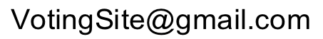 |  | Endnotes by Chapter  The endnote numbers restart at 1 for each chapter.  This book is the first to show Ensemble Councils, Fair Share Voting, and rules of order for Condorcet Tallies.  It is also shows games and graphics from SimElection™.  It compresses much of accuratedemocracy.com (ⓐ) ⓐ/a_primer.htm ⓐ/a_workshop.htm ⓐ/d_stats.htm ⓐ/SimElection.com  Resources, for education and action  The website has free software! ⓐ/z_tools.htm, animations ⓐ/d_stv2d.htm or ⓐ/p_tools.htm, and Web links ⓐ/z_bib.htm  Voting games handout for pages 37-43 is free to download at ⓐ/download/workshop/irv_stv_handout.pdf  FairVote is a nonpartisan catalyst for electoral reforms. It is the best source for news, analysis and resources for voting reform in U.S. cities, states and colleges. FairVote.org has great resources for reform: examples of successful legislation, voter education materials, videos, ballots, editorials, testimonials, research reports...  61

Introduction, Tragedies, Eras and Progress  Amy, Douglas J. Proportional Representation: The Case for a Better Election System. North Carolina on page 30, http://www.archive.fairvote.org/?page=1606  2 Durbin, Kathy. Tree Huggers: Victory, Defeat & Renewal in the Northwest Ancient Forest Campaign, Seattle, Mountaineers, 1996.  3 Hoag, Clarence and George Hallett. Proportional Representation, (NYC, The Macmillan Company, 1926).  4 Duverger, Maurice. "Factors in a Two-Party and Multiparty System," in Party Politics and Pressure Groups (New York: Thomas Y. Crowell, 1972), pp. 23-32.  5 FairVote, Monopoly Politics 2014 and the Fair Voting Solution, http://www.fairvote.org/assets/PowerofPartisanship2014.pdf  6 Lijphart, Arend. Electoral Systems and Party Systems: A Study of Twenty-Seven Democracies (Oxford U. Press, 1994).  8 Statistics on panel 59 compare the stable democracies.  Electing a Leader, Instant Runoff ⓐ c_irv.htm  Chamberlin, Jerry L. Cohen, and Clyde H. Coombs; "Social Choice Observed: Five Presidential Elections of the American Psychological Association" Journal of Politics. 46 (1984): 479-502.  "An Investigation into the Relative Manipulability of Four Voting Systems", Behavioral Science; 30:4 (1985) 195-203.  Merrill, Samuel III. Making Multi-candidate Elections More Democratic. (Princeton University Press, 1988).  2 Voter Turnout in Runoff Elections, Stephen G. Wright, The Journal of Politics, Vol. 51, No. 2 (May, 1989), pp. 385-396.  3 RCV Civility Project www.fairvote.org/rcv_civility_project  Reilly, Ben. Democracy in Divided Societies, 2001, Cambridge U.  Papua New Guinea: Electoral Incentives for Inter-Ethnic Accommodation, http://aceproject.org/ace-en/topics/es/esy/esy_pg  4 Korean election http://en.wikipedia.org/wiki/Roh_Tae-woo http://nimbus.ocis.temple.edu/~jhurewit/history.html tradecompass.com/library/books/armyhb/CHAPT04.04SK.html |  | Electing a Council, Fair Representation ⓐ d_intro.htm  Panel 59 statistics compare stable democracies. ⓐ d_stats.htm  2 Huber, John D. and G. Bingham Powell, Jr., “Congruence Between Citizens and Policymakers in Two Visions of Liberal Democracy,” World Politics v46 #3 (April 1994), 291-326.  4 “Illinois Assembly on Political Representation and Alternative Electoral Systems”, IGPA University of Illinois, Spring 2001. http://www.fairvote.org/media/pep/execsum.pdf  History of cumulative voting, 1870-1970: Three is better than one http://www.lib.niu.edu/1982/iisr04.html  http://archive.fairvote.org/index.php?page=39&articlemode=showspecific&showarticle=1325  4 Roberts, Nigel NEW ZEALAND: A Long-Established Westminster Democracy Switches to PR, (Stockholm, IDEA) www.idea.int/esd/upload/new_zealand.pdf  5 Richie, Rob and Andrew Spenser; “The Right Choice for Elections” Univ. of Richmond Law Review; v. 47 #3, March 2013. lawreview .richmond.edu/wp/wp-content/uploads/2013/03/Richie-473.pdf  http://www.representation2020.com/  6 Krook, Mona Lena. Quotas for Women in Politics: Gender and Candidate Selection Reform Worldwide; (Oxford U. Press, 2009), 123.  Healy, Andrew and Jennifer Pate. 2011. “Can Teams Help to Close the Gender Competition Gap?” Economics Journal, 121: 1192-1204 myweb.lmu.edu/ahealy/papers/healy_pate_2011.pdf  7 http://www.nytimes.com/2016/11/10/upshot/women-actually-do-govern-differently.html ⓐ d_stats.htm  http://www.nytimes.com/interactive/2018/11/10/opinion/house-representatives-size-multi-member.html by The Editorial Board  A democracy can reduce the distance from the voters to the legislators via initiatives, proxies, sortition or consensus seeking (panel 56).  + Green-Armytage, James. “Direct Voting and Proxy Voting”, Dept. of Economics, Bard College. jamesgreenarmytage.com/proxy.pdf  63
5 https://www.fairvote.org/where_is_ranked_choice_voting_used
https://www.fairvote.org/rcv_in_campus_elections 62
Setting Budgets, Fair Share Voting ⓐ p_intro.htm  FSV=STV if $# = voters#, 1 share = $1, and 1 seat costs $# / seats+1.  1 Shah, Anwar ed. Participatory Budgeting; The World Bank Washington, DC; http://siteresources.worldbank.org/PSGLP/ Resources/ParticipatoryBudgeting.pdf  2 Moore, Joe Participatory Budgeting in the 49th Ward, http://participatorybudgeting49.wordpress.com/  In 2014, voters in Cambridge, Massachusetts saw a similar pattern.  3 Tupelo-Schneck, Robert and Robert B. Loring, PB Conference slideshow; NYC, 2012; ⓐ /download/workshop/fair-share-spending.pdf @/download/workshop/gasto-equitativo.pdf  4 News of the Oaks, Leaves of Twin Oaks, Louisa, VA 1995.  5 Oaks, Adder. “Participatory Budgeting in an Income Sharing Community”, Communities: Life in Cooperative Culture; #175, 2017.  Leaves of Twin Oaks, 2013. Base for budget cuts was >50%.  Leaves of Twin Oaks, 2013. The base of support to cut a budget was 55% of the voters; some managers grumbled but did not protest.  Enacting a Policy, ⓐ l_intro.htm c_data.htm l_data.htm  1 Green-Armytage, James. "Four Condorcet-Hare Hybrid Methods for single-winner elections"; 2011; votingmatters.org.uk/ISSUE29/  "Strategic Voting and Nomination"; Social Choice and Welfare; 2014.  Tideman, Nicolaus. Collective Decisions and Voting; (Ashgate Publishing Ltd. Hampshire, England; 2006) page 232.  Green-Armytage, James; Nicolaus Tideman and Rafael Cosman. "Statistical Evaluation of Voting Rules" Social Choice and Welfare; 2016, 46: 183.  1a If A tops B, B tops C, and C tops A, then we have a “voting cycle.” Tally IRV with the options in the top voting cycle. @ l_cycles.htm  1b These follow from Later-no-harm and Later-no-help criteria.  2 See Chamberlin et al, or Merrill above. ⓐc_data.htm ⓐ l_data.htm  3 See the captions on pages 13 and 50. ⓐ c_irv.htm#compare  4 https://en.wikipedia.org/wiki/Primary_challenge  5 Rules of Order accuratedemocracy.com/l_motion.htm 64 |  | Workshop Voting Games, ⓐ a_workshop.htm  1 A ballot by an inventor of FSV http://tupelo-schneck.org:8080/tag/  2 FairVote, “Ranked Voting and Questions About Election Integrity”, "Published October 12, 2013. http://www.fairvote.org/ranked-voting-and-questions-about-election-integrity/  www8.nationalacademies.org/onpinews/newsitem.aspx?RecordID=25120  Election Audits, http://electionaudits.org/ www.verifiedvoting.org  3 Portland Voters Overwhelmingly Support RCV, 2015 fairvote.org/portland_voters_overwhelmingly_support_ranked_choice_voting  4 Krosnick, Jon A. "In the Voting Booth, Bias Starts at the Top", http://nytimes.com/2006/11/04/opinion/04krosnick.html  5 youtube.com/watch?v=oHRPMJmzBBw or v=_5SLQXNpzsk  https://accuratedemocracy.com/d_stv2d.htm ⓐ p_tools.htm  6 https://AccurateDemocracy.com/a_teach.htm  Simulation Examples, www.SimElection.com  Loring, Robert. simelection.com 1996 http:politicalsim.com  https://accuratedemocracy.com/d_stv2d.htm ⓐ p_tools.htm  See Chamberlin et al, or Merrill III, or Green-Armytage above.  Brady, Henry E. "Dimensional Analysis of Ranking Data", American Journal of Political Science. 34 (11/90).  Social Effects and Uses, ⓐ a_goals.htm  1 Bennett-Smith, Meredith. World's Happiest Countries 2013, http://www.huffingtonpost.com/2013/05/28/worlds-happiest-countries-2013-australia_n_3347347.html; Cites UN, OECD.  OECD Better Life Index http://www.oecdbetterlifeindex.org/  2 Susskind, Lawrence and Jeffrey L. Cruikshank, Breaking Robert’s Rules; (Oxford U. Press, 2006). Spanish: Mejor Que La Mayoria, with Francisco Ingouville, (Buenos Aires, Obelisco, 2011)  LiquidFeedback.org Free software to help groups make decisions.  Francis, Fred and Peg. Democratic Rules of Order, 2010, p.19, 24.  3 Group-Process Pattern Language, http://groupworksdeck.org 65

4 https://www.accuratedemocracy.com/l_motion.htm  https://en.wikipedia.org/wiki/Committee_of_the_whole  5 https://en.wikipedia.org/wiki/Democracy_voucher  Ackerman, Bruce; and Ian Ayres. Voting with Dollars: A New Paradigm for Campaign Finance; (New Haven: Yale Univ. Press, 2002).  6 Gifts to "spoilers" are ineffective under Ranked Choice Voting. Multi winner districts make it hard to target money on just one seat.  7 nytimes.com/2018/06/23/opinion/sunday/james-e-hansen-climate-global-warming.html see also, “conservation ... depends on effective governance;” www.nature.com/articles/nature25139.  8 Statistics on page 59 compare stable democracies; notice Math scores.  9 Chalmers, Patrick. “The People Trying to Save Democracy From Itself”, https://theguardian.com/world/2016/jul/02/democracy-tarnished-brand-desperate-need-reinvention  Bouricius, Terrill G. “Democracy Through Multi-Body Sortition: Athenian Lessons for the Modern Day”, New Democracy Institute, Journal of Public Deliberation, Volume 9 | Issue 1; 4-30-2013  Navajas, Joaquin et al.“Aggregated knowledge from a small number of debates outperforms the wisdom of large crowds”, (Cornell University, 2017) https://arxiv.org/abs/1703.00045  10 Tishman, Shari and Albert Andrade, Thinking Dispositions, https://pdfs.semanticscholar.org/57cb/278acf38e9da6490d266260f9a9c50d20da3.pdf Many people use these ways of thinking at times. But fewer have a disposition to use them routinely.  11 https://cyber.harvard.edu/publications/2018/01/communityfiber  Institute for Local Self-Reliance http://www.ilsr.org  On Solar Streets and Wilderness Alleys http://windsong.bc.ca  12 Loring, Robert. “Egalitarian versus Authoritarian Values” https://accuratedemocracy.com/a_quotes.htm#egal  13 See progressive taxes in Wikipedia pages on: Carbon_tax, Consumption_tax#Expenditure_tax, Georgism (land), Financial_transaction_tax (speculation), and Weath_tax.  Piketty, Thomas. Arthur Goldhammer; Capital in the 21st Century, Cambridge MA: The Belknap Press of Harvard Univ. Press, 2014. |  | Some Endorsements  1. “This is the site for learning about democracy.”  —Zoe Weil, author Most Good, Least Harm,  president of the Institute for Humane Education.  2. “... a huge contribution to the democracy cause.”  —John Richardson Jr., former Assistant Secretary of State for Educational and Cultural Affairs, and Chairman of the National Endowment for Democracy.  “Congratulations on a brilliant piece of work.”  —Robert Fuller former President, Oberlin College, author of All Rise, and The Theory of Everybody.  “I like your thoughtful application of the best voting techniques to the PB process.” participatory budgeting  —Tree Bressen, a leading author on group process,  Group-Process Pattern Language, groupworksdeck.org  About My Work VotingSite@gmail.com  In 1990, John R. Chamberlin, and Samuel Merrill III each gave me permission to use their sim results (p. 60-61) to advance a Condorcet-IRV rule. Throughout the 1990s, I created the PoliticalSim™ and SimElection™software. They compared 30 single- and multi-winner rules from around the world and were used in a few universities.  By 1996 I had built the Democracy Evolves website. Then I helped FairVote.org as webmaster and librarian. I have helped Robert Tupelo-Schneck and Twin Oaks Community develop Fair Share Voting for 10 years. 67
https://scholar.princeton.edu/sites/default/files/mgilens/files/gilens_and_page_2014_-testing_theories_of_american_politics.doc.pdf 66
Glossary and Index  Accurate democracy gives groups fair shares of seats and spending.  It cuts scams and enacts a policy that tops all rivals. 4 goals  a Mandate is the legitimacy effective votes loan Panels  to a winner. Contrast a wasted vote. basic goal 9-15, 55  a Majority is more than half of the votes. 9, 12, 28, 50  a Plurality has the most votes–often not a majority.  " rules use yes-or-no voting; contrast RCV. 4, 9, 21, 29-, 59  a Ranked Choice Vote lets you rank your first choice and backups.  a tool for effective votes and fair shares. 12, 38, 46  a Threshold to win, quota or Finish line is the fraction or  percentage of votes a rule requires for a win. 4, 12, 15, 38-, 46  a Wasted vote went to a loser, a winner’s surplus, or a powerless rep;  measures weakness in a voting result. 10-16, 21, 25  a Wrecking amendment ruins a bill’s chances or effects.  Free-rider " don't relate to the main bill. 28, 31, 32  Acronyms and Synonyms Panels  Consensus process; contrast Rules of Order 31, 52-  CT Condorcet Tally or Pairwise Tally 26-28-, 40, 48-50  EC Ensemble Council New 6-, 29, 48-50  FSV Fair Share Voting New 20-22-, 37-, 46-, 53-  FR, Fair Rep, Fair Representation (US),  PR Proportional Representation 5, 14-16-, 42-, 59  RCV Ranked Choice Voting, Choice Voting (US), includes:  STV Single Transferable Vote for Fair Rep 36, 42-45, 48-49  IRV Instant Runoff Voting (US), preferential voting, and  AV Alternative Vote (UK) or Hare for SMD 12-, 34-36, 54  SMD Single-Member District elects one rep. 4, 14, 17 |  | Answers  Panel  9. No one got a majority. K got a plurality; M was second best.  10. M wins. Votes that move count the same as others.  11. Plurality leaves more wasted votes, thus has a weaker mandate.  18. Fair Representation elects more women.  24. A vote for a loser transfers, so it does not waste your power. None. A vote for a landslide winner uses little money.  27. Yes, the teal person beside L. No, only central reps.  42. No. Not if each has an equal membership. Optional.  44. Empowering, fair and easy for voters, i.e. strategy free  45. 'Fruits & Nuts' is likely to win the plurality.  46. The pink diamond with only 3.7% is the first to lose.  49. Less than a sixth of the votes are wasted. These winners seem to be diverse, balanced in all 4 quadrants, well centered by the light-blue circle, with no reps on the fringe.  50. The next winner is the evergreen labeled J in the lower left.  56. Yes and yes, it seems, but perhaps small cold nations with strong unions and middle classes help women, education, health, jobs...  Voting rules help us guide public and co-op institutions for democratic freedoms and their companion, widely-shared prosperity:  utility grids: road, water, electric, ISP, WiFi.  services: election equipment, police, courts, libraries, schools, clinics, banks, meeting places and social media, http://nplusonemag.com/socialize-social-media  financial transaction tax (Tobin), land-value tax (Georgist). 69

